What’s The deal with Inter Process Communication?
INTERPROCESS COMMUNICATION REPORT
Alwyn Barnard 28430093
Mr Henry Foulds
ITRW 316 – Report 2
12 March 2019

Table of Contents
Introduction to Inter Process Communication (IPC) 2
Race Conditions in Inter Process Communication (IPC) 2
Critical Regions in Inter Process Communication (IPC) 3
Mutual Exclusion with Busy Waiting 3
1. Disabling Interrupts 4
2. Lock Variables 4
3. Strict Alternation 4
4. The Peterson Solution 5
Semaphores in Inter Process Communication (IPC) 5
References 7

Introduction to Inter Process Communication (IPC)
To understand the concept of Inter Process Communication we must look at processes first. A Process is an instance of an executing program with all its data and registers (Tanenbaum & Bos, 2014:82). These processes need to frequently communicate with the components of the Central Processing Unit (CPU) and with each other. For example, Process A needs to get Value A and Value B from the user. Then Process B needs to add these two values together. Process C needs to output this result on screen for the user. In this example, we see that the processes needed to wait for each other to finish and then share memory to execute their own instructions.

This is where the concept of Inter Process Communication comes into play. Inter Process Communication or IPC is a mechanism that allows processes to communicate with each other and effectively synchronise information that won’t hinder the other’s working. This is done in two ways: Shared memory and Message passing (Pandey, s.a.). We will now look at a possible error when it comes to IPC.

Race Conditions in Inter Process Communication (IPC)
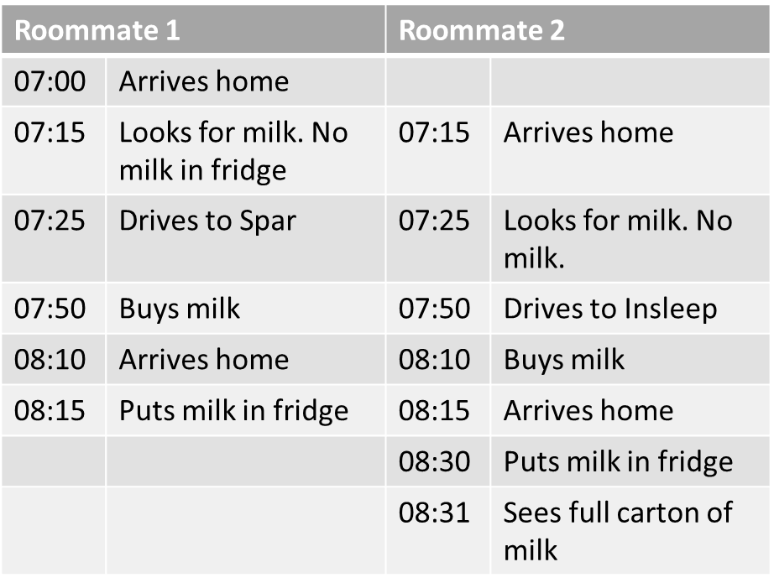

Race conditions refers to when two processes both access shared data from the main memory or from a shared file. Process X accesses the data, does a calculation and then changes the value. Then Process Y accesses the same value that was changed by Process X and changes it again after doing a calculation. If Process Y accessed the value first, the outcome could have been a different result or even a catastrophic error. For example (Chun, s.a.:2)

(Photo by Engin Akyurt from Pexels)

With race conditions the process that runs the race first wins the opportunity to execute and use the data first and thus the end result would then be dependent on who wins.

Critical Regions in Inter Process Communication (IPC)
From the above example we can see that Race Conditions can be detrimental or fatal to a program and its result, e.g. Process A multiplies two values and process B gets their sum.
Process A runs first: 4 * 4 = 16 Process B runs first: 4 + 4 = 8
Then process B: 16 + 2 = 18 Process A then runs: 8 * 2 = 16
We can clearly see that the process order has a huge effect on the outcome. But how would we go about ensuring the correct process and only a single process accesses the specific shared memory space? With Critical Regions.

A Critical Region is the part of a program that has the shared file or data used in the program. To avoid Race Conditions, we need to ensure no two processes are in their Critical regions at the same time.

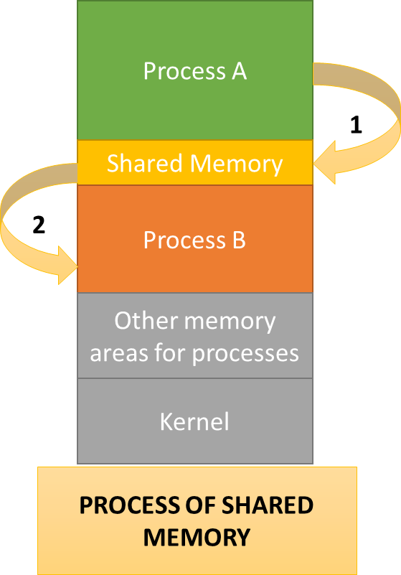
A good formula for the Race Condition has the following four traits:
- No two processes can be in the Critical Region. together
- We cannot make assumptions about the attributes of a process like speeds or number of CPUs.
- No process outside its Critical Region can block another process.
- No process may be in an infinite loop in waiting to enter or exit its critical region
(Tanenbaum & Bos, 2014:117)

These four traits can be summarized using the word, mutual exclusion.

Mutual Exclusion with Busy Waiting
Mutual exclusion is the practice of implementing various proposals that would allow a process to continue its work in updating the shared memory in the critical region whilst, no other process will enter that critical region. We will now look at ways to allow mutual exclusion by briefly investigating four of the following concepts: Disabling Interrupts, Lock Variables, Strict Alternation, The Peterson Solution and the Test and Set Lock (TSL) Instruction.

1. Disabling Interrupts
When a process enters the critical region then the Kernel will then disable interrupts while the process is in the critical region. Just before exiting the critical region, the interrupts will be enabled again. Thus, no secondary process will be allowed to interrupt and cause race conditions (Kent, 2009). This is a simple solution but not very effective. Sometimes processes need interrupts or need an interrupt to end that process. The risk is that this process can run forever. This is not a good general solution since giving a user process the power to turn off interrupts is very risky.

2. Lock Variables
A lock variable is a shared variable that contains a value to show if there is a process in the critical region. For example, If the lock variable contains 0 then the process can enter the critical region, otherwise it will wait until the lock variable changes from 1 to 0.
The problem here is that two processes can both test the lock variable, see it is 0, start executing and then change the lock variable to 1, but that gives us the same issue we had with race conditions. This is not an effective solution (Tanenbaum & Bos, 2014:119).

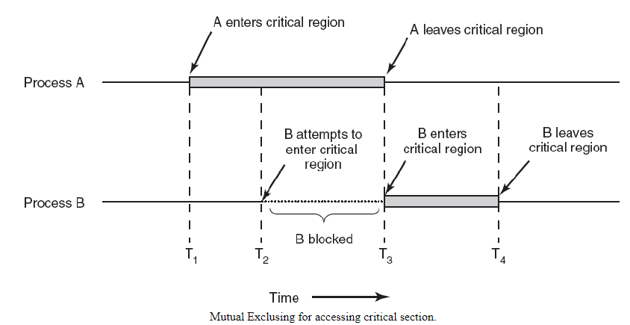

3. Strict Alternation
With Strict Alternation an integer variable, usually called turn, and keeps track of which process’ turn it is to execute. The variable starts at 0 when Process A runs and enters the Critical Region. Process B would also test the turn variable and find it to be 0. It will then enter an infinite loop that tests the turn variable and only exits when the variable is 1. This is a concept called Busy-Waiting (Kent, 2009).

4. The Peterson Solution
A software solution was designed to counter the Mutual Exclusion problem without using Strict Alternation. This solution combines Lock Variables and the idea of taking turns. The solution uses two procedures i.e. enter_region(int process) and leave_region(int process).
Before entering the Critical Region the process will call its own process number as the process variable. Thus, if the next process calls enter_region then it won’t execute and cause a Race Condition since its process number doesn’t satisfy the algorithm. The first process will then call leave_region with its own process number as parameter and exit the Critical Region and increment the loop variable that determines which process may execute (Tanenbaum & Bos, 2014:121).

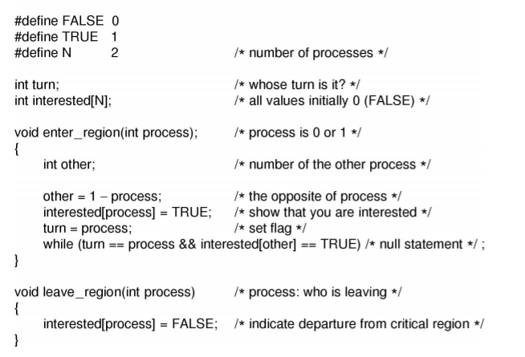

(Tanenbaum & Bos, 2014:121).

Semaphores in Inter Process Communication (IPC)
A different solution to Inter Process Communication and the problems it causes was proposed in 1965. The concept of a Semaphore was introduced: An integer variable that has either a zero value or some positive value that depicts that there has been or has not been any wakeups called by a process (Tanenbaum & Bos, 2014:127).

E. W. Djikstra believed that there had to be two operations. An UP operation and a DOWN operation. The DOWN operation will check if the Semaphore value is more than 0. If it is, then it will decrement that value, symbolizing that one wakeup process has been used, and then executes. If the value is 0, then it will halt the process and not execute the DOWN operation’s instructions. The Semaphore is an ideal solution because whilst it is executing the DOWN operation’s instruction no other process can execute enter the Critical Region, thus eliminating the chance of a Race Condition (Lai Yu, 2010).

The UP operation in the solution is responsible for incrementing the Semaphore value. If there are processes that are sleeping and waiting to be executed by the Semaphore and corresponding process; the UP operation will wake up one process and load it into the DOWN operation. When one process was allowed to execute the Semaphore value will still be 0 since it had to also execute a DOWN operation which decremented the value. Just as with the DOWN operation, when an UP operation is executing, no other process can execute. This also avoids any chance of Race Conditions (Tanenbaum & Bos, 2014:127).

References
Chun, RK. s.a. Race conditions, critical sections and semaphores. http://www.sjsu.edu/people/robert.chun/courses/cs159/s0/Day-8---Race-Semaphores.pdf Date of access: 09 Mar. 2019. [PowerPoint Presentation].
Kent (University of Kent). 2009. Interprocess communication. http://www.personal.kent.edu/~rmuhamma/OpSystems/Myos/intProCom.htm Date of access: 09 Mar. 2019.
Lai Yu, T. 2010. California State University, San Bernardino. CSE 460 Operating systems lecture notes. http://www.csci.csusb.edu/tongyu/courses/cs460/notes/interprocess.php Date of access: 09 Mar. 2019. [PowerPoint Presentation].

Pandey, D. s.a. Inter process communication. https://www.geeksforgeeks.org/inter-process-communication/ Date of access: 09 Mar. 2019.

Tanenbaum, A. & Bos, H. 2014. 4th ed. Boston, MA: Dorling Kindersley Pearson Education.

